SE Webinar #2 Application of Standards
Application of Supported Employment Standards

Handout # 2

SE Referral
DARS 1610

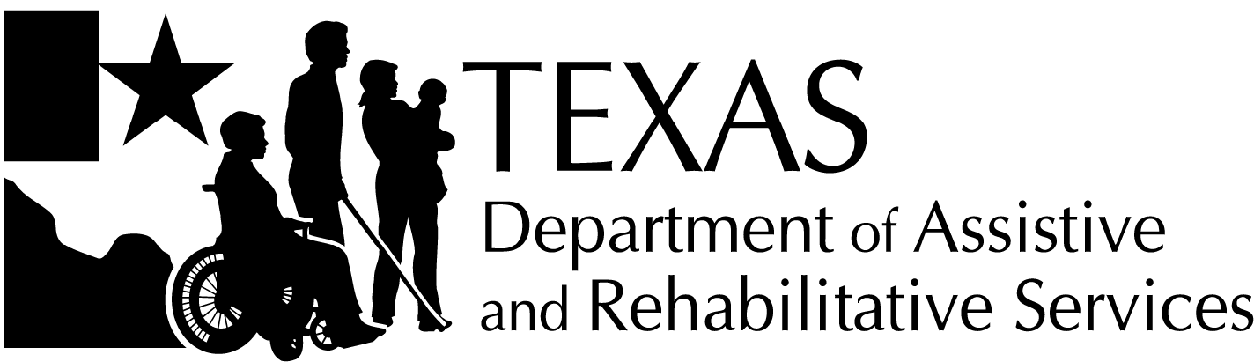 | Division for Rehabilitation Services  Supported Employment Service & Supported Self-Employment —  Referral
General Instructions
- Refer to the DRS Standards for Providers for additional details.
- Complete the form electronically answering all questions.
- Before faxing, emailing encrypted, or mailing to the provider, review this form to ensure that all questions have been answered.
- Note: The DARS staff collects the information and completes all sections of this form.
Date of the Referral: 8/16/14
Referral for: X Supported Employment Services Supported Self-Employment Services
- Consumer Identification Information
Consumer’s name:
Jorge
Street address (include apartment number if any):
333 Bachman Blvd
City:  Dallas |  | State:  TX | ZIP code:  75214
Primary contact number:  (214) 456-7891 |  | Secondary contact number:  (214) 345-6789
Email address:
NA
DARS Case Id:  123456 |  | Date of birth:  1/15/1991
Consumer disability:
IDD, Autism
- Alternate Contact Person Identification Information
Alternate contact’s name:
Maria and Jorge (Jorge’s mother and father)
Alternate’s primary contact number:  (214) 456-7891 |  | Alternate’s secondary contact number:  (214) 345-6789

- Additional Information Provided by DARS at Referral
Enter X to select all that apply.
X IPE copy | Vocational testing
X Medical and/or psychological reports | Work history collected by DARS
X Case notes (for example. eligibility, assessment and planning, etc.) | Work references collected by DARS
X Benefits Planning Reports from CWICs | Functional Capacity Exam Results
Other: | Other:
- Counselor Contact Information
Counselor’s name: Happy Counselor
Counselor’s primary DARS office: Dallas
Counselor’s DARS office street address (include suite number if any):
222 Griffin
City:  Dallas | State:  TX | ZIP code:  75218
Counselor’s primary contact number:  (214) 123-4567 | Counselor’s secondary contact number:  (214) 765-4321
Email address:
Happy.counselor@dars.state.tx.us
- Provider Chosen by the Consumer for Placement Services
Provider’s name:
Super SE Provider
Email address:
susperse@google.com
Provider’s phone number:  (214) 555-5555 | Provider’s fax number:  (214) 555-5556
- Supported Employment Service—Plan Meeting or
Supported Self-Employment Service Plan Meeting
Location: 333 Bachman Blvd
Date: 11/1/14 | Time: 2pm
- Additional Comments, if any
Jorge applied for DARS services with the assistance of his parents. Jorge states that he wants to work in a “real job” in the community. Jorge is a 23-year-old man who lives with his mother, father, paternal grandmother and one older brother. Using funding through Home and Community-Based Services (HCS), a Medicaid waiver, he goes to a day habilitation program 5 days a week. His family reports that Jorge was much happier when he was at school because he really liked the idea of working. They feel that he can do more than he is being asked to do at the day habilitation program. His functional needs supports include communication, self-care, self-direction, and work skills and he will need extended services to maintain employment. Based on all of the information gathered, it has been determined that Jorge needs supported employment to be successfully employed in the community.

